Relatório

- Utilizamos
7 Jumpers
1 Resistor
1 Micro Servo
1 Placa Arduino
1 Protoboard

2) Esquema do Tinkercad
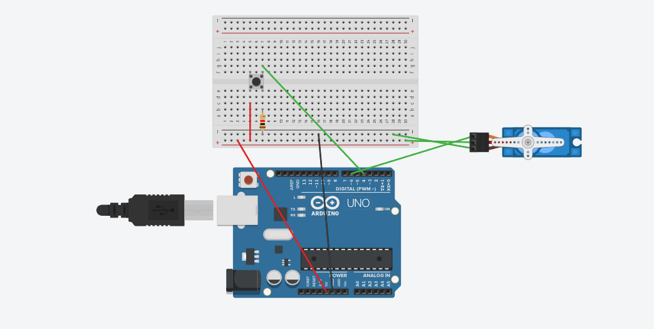

3)Código
digitalWrite(3, LOW);
delay(1000); // Wait for 1000 millisecond(s)
} #include <Servo.h>
Servo Garra;
int p=0;

void setup() {
// put your setup code here, to run once:
Garra.attach(6);
Serial.begin (9600);
pinMode (4, INPUT);

}

void loop() {
if(digitalRead(4)== HIGH)
{
if(p==0){

Garra.write(-90);
delay(1000);
p=1;}
} // put your main code here, to run repeatedly:
else
{
Garra.write(90);
delay(1000);
p=0;
}
}

4)Foto:

